Let’s Talk… A common language and understanding of emotional wellbeing and mental health
A joined-up approach to support the emotional wellbeing and mental health of children and young people

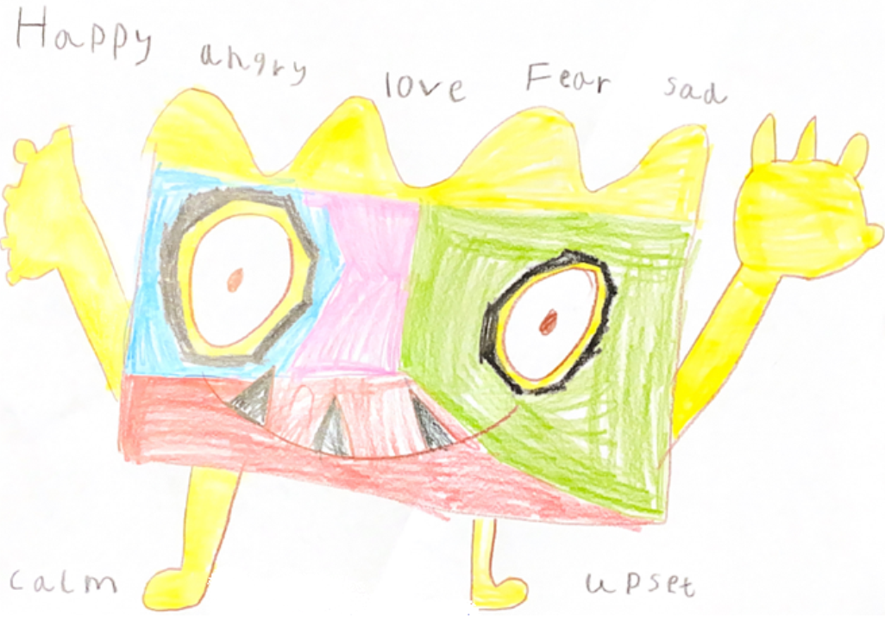
Colby, age 6

  - A Guide for Families
January 2021



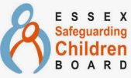





Contents
Title | Purpose | Page
Introduction | The purpose of this guidance, who it is for and how it came about | 2
Helpful & unhelpful language | Examples of unhelpful language and how we can adapt it to be more helpful | 2
Understanding the levels of intervention across Education, Health & Care | Making sense of the varying approaches to intervention from our services | 4
Risk & protective factors | Listed factors relating to the child/young person, family, school and community | 5
What Emotional Wellbeing & Mental Health looks like at different levels of need | A table to define and understand the different levels of emotional wellbeing & mental health | 6
Resources & Contacts | A selection of resources and contacts which may be useful in supporting emotional wellbeing & mental health | 9
Glossary & Acronyms | Key terms and phrases explained | 10
Acknowledgements | Thanks to those who contributed to the creation of this guidance | 12
References | Sources on information that informed this guidance | 12

Introduction
What our children hear us say shapes how they understand, see the world and what they learn about themselves. This includes how they talk about emotional wellbeing and mental health.
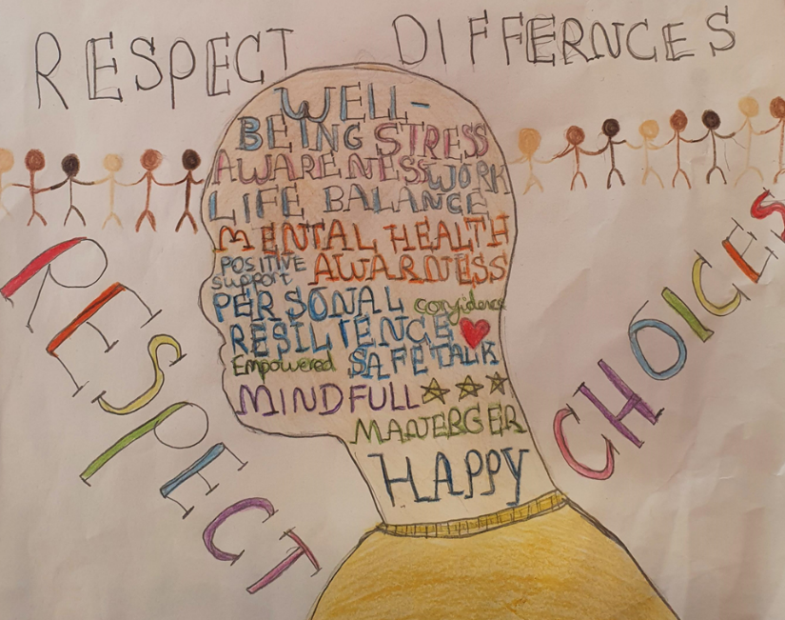
The information in this guidance is helpful for supporting all children and young people. It provides a shared understanding of emotional wellbeing and mental health. We hope that everyone will use this common language, so that everyone feels understood and can plan for support. There are three versions of this guidance. This one for families, one for children and young people and another for school staff and other services. We hope this builds everyone's confidence.
“Mental health is defined as a state of wellbeing in which every individual realises his or her own potential, can cope with the normal stresses of life, can work productively and fruitfully, and is able to make a contribution to her or his community.” (Young Minds, 2017).
Emotional wellbeing and mental health mean different things to different people. We all have mental health and we must look after it, getting the right support at the right time.

Helpful & unhelpful language
Language shapes how we understand things about ourselves and others. Children, young people and families have shared that they hear unhelpful words and phrases which can make them feel judged. This has got to change.
We need to use helpful language to make sure that everyone feels understood and empowered through their experiences. It is vital that this begins with changes in language.
This will take time and starts with everyone reflecting on the words they use to describe emotional wellbeing and mental health. We also need to remember it’s not just what we say, it’s also how we say it. We may not get this ‘right’ every time, but being willing to try we can make positive changes if we all work together.
This table shows how some of the unhelpful language we hear can be changed to more helpful language. This will promote compassion and kindness, hope, connection and belonging.

Examples of unhelpful language | Our preferred language (helpful language)  *Explanations of these terms can be found in the Glossary.
Vocabulary:  Behaviour  Naughty  Defiant  Manipulative  Tantrums  Phrases:  “Just want people to feel sorry for them”  “Red mist”  “Doing it on purpose” | Communicating behaviours*  “I wonder if…”
Vocabulary:  Rough  Violent  Aggressive  Refusal  Rude  Phrases:  “Kicking off”  “Meltdown”  “Out of control” | Stress & distress  Hyper-arousal​ (fight/flight)  Hypo-arousal (freeze/shutdown/disassociation)
Vocabulary:  Dramatic  Emotional  Hormonal  Feral  Disturbed  Crisis  Phrases:  “Overreacting”  “They didn’t mean it” (related to self-injury) | Dysregulation  Outside their window of tolerance​*  Overwhelmed  The CYP requires:  Co-regulation​  Self-regulation​
Vocabulary:  Broken  Surly  Dangerous  Phrases:  “There’s nothing we can do for them”  “Causing harm to others”  “Harmful to others” | Adaptive response​*  Building resilience  Risk  May have experienced/be experiencing Trauma/Adverse Childhood Experiences*  Compromising the safety to themselves and others
Vocabulary:  Over sensitive  Attention seeking  Phrases:  “It’s not that serious” | Attachment/connection​ seeking  Anxiety  Separation anxiety  Avoidance/withdrawn  Not feeling safe yet
Vocabulary:  Unstable  Fragile  Odd  Special  Nutter  Mad  Phrases:  “Maybe it’s not that bad”  “A few sandwiches short of a picnic” | Emotional wellbeing and/or mental health difficulties  Neuro-diverse*  Emotional literacy skills  Social and emotional development
It may be useful to use the helpful language in the table to support change the way emotional wellbeing and mental health is talked about. This might be useful when supporting One Plans, Education, Health and Care Plan Needs Assessments (EHCP) and Team Around the Family Plan (TAF).

Understanding levels of intervention across Education, Health and Care
Education, Health and Social Care use different models to describe need. This can create confusion. Here is a simple explanation of each model:
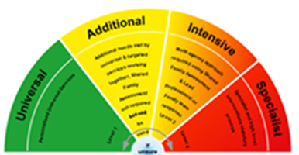
Health Model: iThrive Social Care: Essex Windscreen of Need
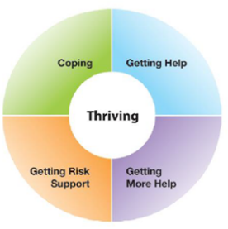

Education: SEND Code of Practice

Here you can see them combined in one model:
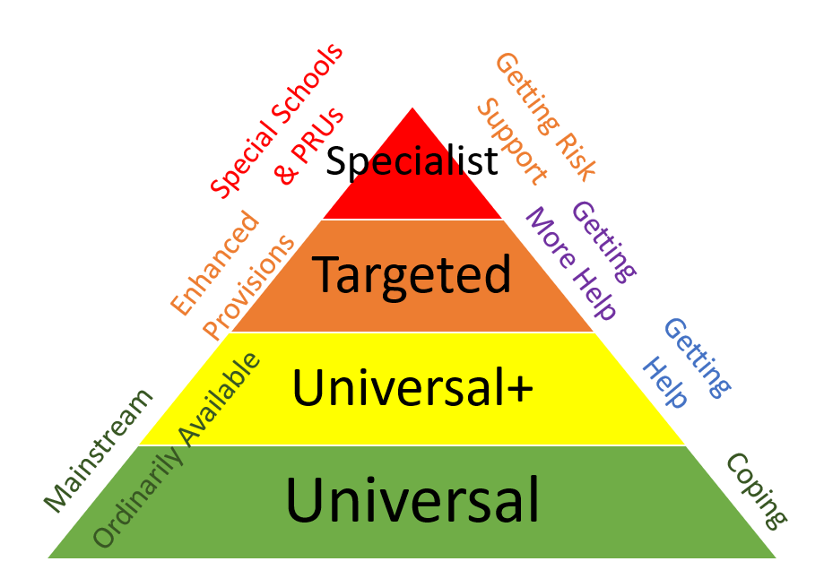

Children and young people may not access services at the same ‘level’ or for the same length of time. Accessing support from one service does not mean that they will also access that level of support from another service. For example, a child or young person may be in a mainstream school/setting accessing a ‘Universal+’ offer, and also ‘Getting risk support’ from the NHS.

Risk & Protective Factors
We all have a range of risk and protective factors which affect their experiences. This includes emotional wellbeing and mental health. Families do the best they can with the resources available to them and the knowledge they have. Understanding these factors can help us make small positive changes. These small changes could make a big difference.
Children and young people have risk and protective factors in these four areas. To learn more about risk and protective factors please speak to your school or other supportive services.

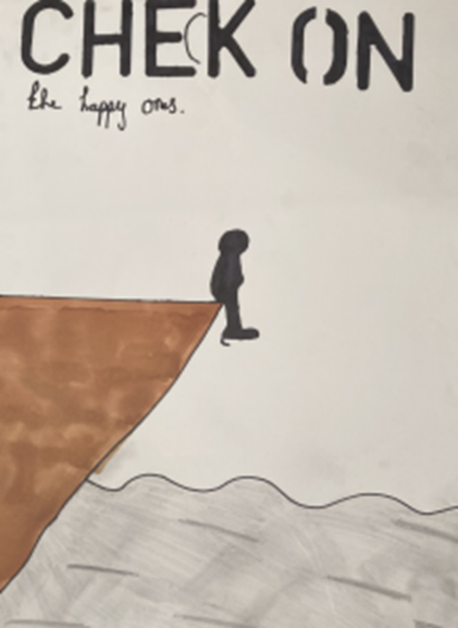

“I feel very passionate about art and mental health for young and old children who feel like they can’t reach out or speak up. This is why on my poster I chose to draw a small ‘c’ to represent those who may not have the courage to.”
Rebecca, age 11

What Emotional Wellbeing and Mental Health looks like at different levels of need
This table provides a starting point to understand emotional wellbeing and mental health at different levels of need.
This attempts to offer some clarity and transparency to support users to navigate the support available.
This table can:
- Help support conversations about emotional wellbeing and mental health
- Support us to work together to find solutions.
- Helps us to understand what emotional wellbeing and mental health needs can look like at different levels.
- Offers transparency about what support is appropriate at different levels of need.
- Manage expectations.
- Build families confidence in their contributions.
- Provides information which can support assessment and reviews.
This table won’t:
- Fit children and young people into a box or provide a diagnosis
- Provide a list of everything that needs to be considered.
- Provide a list of all support that is available
- Replace conversations or assessments to identify what is best for the child
- Give automatic access to a service or intervention

Ordinarily Available / Universal / Coping | Ordinarily Available / Universal+ / Additional / Getting Help | Targeted / Intensive /  Getting More Help | Specialist / Getting Risk Support
Good emotional wellbeing and resilience | Sporadic emotional wellbeing needs  Tier 1 characteristics are likely to be present but may not be sustained consistently over time. | Regular mental health needs  CYP may not present with the below description every day, however it is regular and the length of time is causing concern. | Persistent/ complex/ acute/ chronic mental health needs  CYP presents with the below description most days and over a sustained period of time.
C/YP may present as:  Mostly protective factors, resilient: able to cope with everyday set-backs, fully engaged and participating in learning, motivated and ambitious, self-regulating, physical well and active, full of energy, consistent, socially active, taking safe risks, meeting their developmental milestones. | C/YP may present as:  More protective factors than risk factors, developing emotional wellbeing and literacy skills, co-regulating required, worrying, nervous, distressed/stressed, irritable, sad, disengaged in learning, vigilant, safe-uncertain risk taking (e.g. smoking, hiding in familiar setting), seeking sensory feedback. | C/YP may present as:  - More risk factors than protective factors, withdrawn, avoidant and isolated, angry, disengaged in multiple aspects of life, socially withdrawn, hypervigilant, self-conscious, scared, worried about experiencing setbacks, unable to track their own progress, have ‘glimpses’ of hope but can at times feel hopelessness, unsafe-uncertain risk taking, self-injuring. | C/YP may present as:  Mostly risk factors, restricted in their daily functioning, easily enraged, unable to fall or stay asleep, exhausted, unable to perform, isolated, avoiding social events, experiencing psychosis symptomology, persistent depression, persistent feelings of hopelessness and emptiness, unsafe-certain risk taking, severe self- injuring,
C/YP may communicate through:  Positive attachments (with peers and adults), positive sense of self, good emotional literacy skills, normal fluctuations in mood, healthy sleeping patterns, full attendance, awareness of how to keep themselves safe and take health risks (e.g. online, social groups etc), knowing how to access support from a range of sources, co-regulation and self-regulation skills, healthy habits (eating, exercise), readiness for transitions (school readiness, transitions between key stages, preparing for adulthood etc). | C/YP may communicate through:  Additional emotional wellbeing areas of development identified, separation anxiety which undermines secure attachments in different contexts/settings, low sense of self-worth, changes in sleeping/eating/toileting/self-care, low energy/mood, some low motivation, decreased social and physical activity, psychosomatic symptoms (e.g. headaches, non-medical physical complaints), occasional non-attendance. | C/YP may communicate through:  Fluctuations in emotion (e.g. sadness, anxiety, anger), intrusive thoughts, low mood/depression, reduction in personal hygiene, restless/disturbed sleep, persistent psychosomatic symptoms, difficulties with maintaining positive social interactions with others, insecure attachments in some/multiple contexts/settings, persistent low motivation, decreased social and physical activity, persistent non-attendance, changes in eating habits, substance mis-use, emerging suicidal thoughts. | C/YP may communicate through:  Persistent lack of motivation or ability to carry out daily routine and tasks, excessive anxiety, non-attendance, suicidal ideation with planned intent, attempted to take own life, planned intent to hurt self or others in some way, substance dependence, physical illness, insecure attachments, not trusting others (including family and friends), eating disorders.
Family engagement can include:  Engage in school events (e.g. parents evening), seek parenting advice and support through accessing websites /forums /helplines /groups (e.g. Young Minds Parent Helpline, Family Lives and parenting groups), accessing Primary Care support for health and wellbeing needs (e.g. GPs), seeking support for financial, employment and housing needs when required. | Family engagement can include:  All of Tier 1 with the following additions –  Exploring early signs of concerns, attending personalised planning meetings, supporting attendance, accessing early help support (e.g. Paediatricians, Counsellors etc). | Family engagement can include:  All of Tier 1 & 2 with the following additions –  Engage in assessments (e.g. EHCP/NA, Child Development Centre, etc), support treatment plans, share relevant information, co-produce, agree and implement risk assessments, access and engage with targeted support e.g. Multi-agency & Multi-disciplinary teams. | Family engagement can include:  All of Tier 1, 2 & 3 with the following additions –  Engage in specialist multi-disciplinary/ agency meetings (e.g. CETR), maintain risk assessments.
Provision:  Pupil – Full-time placement in a school/setting which provides compassion, kindness, hope, connection & belonging (TPP values), school council/pupil voice, curriculum (including PSHE), reasonable adjustments, group interventions, extra-curricular activities, school nurse, health visitor, mentoring, outdoor space, local activity clubs, One Page Profile, APPs.  Family - Open door policy, coffee mornings, additional meetings with family/staff, parent/carer workshops, appropriate housing, social networks, faith groups, Local Offer website, frequent and transparent school/settings communication.  Staff – Valued staff wellbeing, support mentoring from SLT, access to consultation, opportunities for CPD (including TPP), training for use of evidence-based tools/assessments, online resources/helplines, Provision Guidance Toolkit, Local Offer Website. | Provision:  All of Tier 1 with the following additions:  Pupil – Interventions to support skill building (e.g. co-regulation, emotion coaching, SMART thinking), safe space, reintegration planning, de-sensitisation programmes, in-school counselling, One Planning, peer mentoring, short-term EWMHs support (e.g. groups).  Family – MHFA Training, support accessing targeted signposting to meet any identified needs, Early Help Plan, partnership support with SEND Engagement Facilitators, Essex Educational Psychology Service Parent Helpline.  Staff – SENCo and pastoral support teams, SEMH outreach/training support (e.g. EnPros, Education Psychology Service, Inclusion Partners), MHFA Training, Mental Health Support Teams, EWMHs School Training offer. | Provision:  All of Tier 1 & 2 with the following additions:  Pupil – Personalised curriculum in their school/setting, SEMH enhanced provision outreach support/placement, community/EWMHs therapies/counselling, NHS 111, community paediatrician, EHCP assessment being considered.  Family – Family Solutions, community family therapy, accessing targeted training/coaching.  Staff – Advice/outreach from SEMH Special School, support from SEND operations Team. | Provision:  All of Tier 1, 2 & 3 with the following additions:  Pupil – Statutory services, EHCP, SEMH Special School placement, emergency services, Mental Health Inpatient Unit, Ongoing care planning (e.g. rehabilitation, relapse prevention), FCAMHS therapies/counselling,  Family – Social Care, specialist family therapy, specialist training/coaching.  Staff – Specialist advice/outreach from specialist services.

Resources & Contacts
Essex Local Offer – Emotional Wellbeing and Mental Health: http://www.essexlocaloffer.org.uk/category/emotional-wellbeing-and-mental-health/
EWMHS: https://www.nelft.nhs.uk/services-ewmhs/ or call the SPA on 0300 300 1600.
Effective Support Portal: https://www.essexeffectivesupport.org.uk/ or call 0345 603 7627.
Key documents/guidance:
- One planning: http://www.essexlocaloffer.org.uk/one-plan-templates/
- Effective Support for Children and Families Guidance: https://www.escb.co.uk/media/1479/effectivesupportbooklet2017v5-final.pdf

Directories:
Directory name | Provides | Link
Essex Child & Family Wellbeing Service | Provide a range of child and family services throughout Essex that are free at the point of delivery. | https://essexfamilywellbeing.co.uk/
Essex Effective Support | The Effective Support Windscreen illustrates how Universal, Early Help (Additional and Intensive) and Specialist services in Essex are provided. Website includes Children & Families Hub Request for Support Portal. | https://www.essexeffectivesupport.org.uk/
Essex Local Offer | Online directory of Services and support for special educational needs and disability. | http://www.essexlocaloffer.org.uk/
Essex Map | Online resource to help find the groups, services, and activities who are working to better the community, rather than focusing on profit. | https://www.essexmap.co.uk/
SNAP | Special Needs and Parents includes directory of support for families. | http://www.snapcharity.org/index.php/information
Southend Essex Thurrock Domestic Abuse Board (SETDAB) | Southend, Essex and Thurrock domestic abuse partnership website, providing advice and information on services for those affected by domestic abuse | https://setdab.org/
Getting Help in Essex | Find support groups, local services and resources to help you cope during the coronavirus (COVID-19) pandemic. | https://www.essex-gethelp.uk/

Glossary & Acronyms
Term | Definition
Adaptive response | The perception of a threat leads to a response within the body for dealing with the threat. This is an adaptive response as it prepares the body to take the necessary action (fight, flight, freeze, etc).
Adverse Childhood Experiences | A wide range of circumstances and experiences that impact on a child’s development. These may be through stress or deprivation. In Essex we take an adverse experience to be any that in an on-going or severe way compromises whether a child is safe.
Alternative Provision | A school/setting which provides an alternative education for pupils who do not attend mainstream or special schools.
CCG | Clinical Commissioning Groups are our local health providers. There are 7 across Southend, Essex & Thurrock.
CETR | Care, Education Treatment Reviews assess the need for hospital stays for children and young people with learning difficulties and/or autism and complex mental health needs.
Communicating Behaviour | All behaviour is communication. We must act as ‘stress detectives’ to explore what a CYP is telling us through their communicating behaviours.
Directory | A list of provisions, resources, tools, etc.
Discharge | When an individual’s care is ceased from a service provider. Usually used in health contexts.
Early Intervention | Provision which is put in place to prevent further escalation of need.
EHCP | Education, Health & Care Plan. A statutory plan outlining targeted/specialist support for pupils with SEND.
Enhanced Provision | An educational setting which provides targeted, short-term education for pupils with additional needs.
EP | Educational Psychologist.
EWMH | Emotional wellbeing and mental health.
EWMHS | Emotional Wellbeing & Mental Health Service.
FCAMHS | Forensic Child & Adolescent Mental Health Service.
In-patient | A person who experiences a stay in a hospital setting.
IP | Inclusion Partner (part of the SEND Quadrant Teams in Essex).
Mainstream | An educational setting which provides universal education for the majority of pupils.
Multi-Agency Team, with examples | A Multi-Agency Team is made up of a group of professionals from different services. They work together in collaboration with joint responsibility to ensure that the whole needs of a child or family are met.
Multi-Disciplinary Team, with examples | A Multidisciplinary team is made up of a group of health care professionals. They are members of different ‘disciplines’ e.g. Psychiatrist, Psychotherapist, Clinical Psychologist, nurse and occupational therapist etc.
NELFT | North East London Foundation Trust are the providers of EWMHS in Southend, Essex & Thurrock.
Neuro-diverse | Conditions such as autism, dyslexia and ADHD which occur naturally. These can create differences in the way they understand situations, socialise and learn. They may also have differences in attention, mood and other processes.
One Page Profile | A One Page Profile shows all the important information about a person on a single sheet of paper. There are three simple headings: what people appreciate about me, what’s important to me and how best to support me.
One planning / One Plan | Essex’s approach to the Graduated Response. One planning is a process which is used to create a One Plan: a collaborative plan of support.
PRU | An educational setting for pupils who have been excluded from mainstream schools/settings.
Quadrant | A geographical area in which Essex County Council support is structured. These are Mid, South, North East and West.
Reasonable adjustments | Changes that a school/setting must make so that all pupils can access and enjoy their education.
Safeguarding | Measures to protect the health, well-being and human rights of individuals, which allow all people to live free from abuse, harm and neglect.
Self-injury | A coping strategy used by individuals to manage their emotions. This might include pulling hair, picking/scratching skin, hitting self, cutting, etc. Also referred to as self-harm.
SEND | Special Educational Needs and Disabilities.
SPA | Single Point of Access for contacting EWMHS.
Special School | An educational setting which provides specialist education for pupils with a SEND.
STP | Sustainability & Transformation Partnerships. Local NHS organisations and councils working together to improve health and care in the areas they serve. There are 3 which cover Southend, Essex & Thurrock: Mid & South Essex, Suffolk & NE Essex and Hertfordshire & West Essex.
Threshold | A point at which criteria changes and indicates a need to alter/change provision.
Tier / Level | A category of need or support which is defined by criteria and varying degrees of intensity.
Transition | A point of change, such as changing year groups or moving to a new school/setting.
Trauma Perceptive Practice (TPP) | The Essex approach to understanding behaviour and supporting emotional wellbeing. This is a free comprehensive training programme for all Essex schools/settings.
Window of Tolerance | The window of tolerance is a term used to explain and help adults understand the stress response system. Every individual has a unique window of tolerance. When they are within their window of tolerance, they feel regulated, calm and able to learn, love and play to the best of their ability. When they experience a stressor, making them feel worried or scared, they are pushed outside of their window of tolerance. The task for the adult is to widen the window.

Acknowledgements
This guidance is created with the support of the Emotional Wellbeing & Mental Health Strategic Board, including members from:
 |  |  |   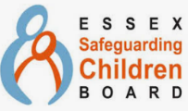 | 


Additional thanks to all the CYP and parents who have contributing to our research:


Special thanks to Colby, who designed the image for our front cover. We particularly liked how he incorporated so many emotions into one character, demonstrating that all emotions are normal and within us at all times. Thank you to all the children and young people who sent us pictures to include in this document.

References
Anna Freud Centre for Children and Families (2020) Heads Together; Mentally Healthy Schools. Available at: https://www.mentallyhealthyschools.org.uk/risks-and-protective-factors/learnmore/ Accessed: 16.6.2020.
Department for Education (2014) SEND Code of Practice. Available at: https://www.gov.uk/government/publications/send-code-of-practice-0-to-25 Accessed: 18.06.2020.
Department for Education (2018) Mental Health and Behaviour in Schools. Available at: https://assets.publishing.service.gov.uk/government/uploads/system/uploads/attachment_data/file/755135/Mental_health_and_behaviour_in_schools__.pdf Accessed 18.06.2020.
Essex County Council (2018) Effective Support Portal. Available at: https://www.essexeffectivesupport.org.uk/ Accessed: 19.06.2020.
Essex Safeguarding Children’s Board (2018) Thematic Review of Teenage Suicides within Essex in 2017.
NELFT NHS Foundation Trust (2020) i-Thrive. Available at: https://www.nelft.nhs.uk/i-thrive/ Accessed: 18.06.2020.
Ofsted (2019) Local Area SEND Inspection. Available at: https://reports.ofsted.gov.uk/provider/44/80468 Accessed: 16.06.2020.
Young Minds (2017) Wise Up: Prioritising Wellbeing in Schools. Available at: https://youngminds.org.uk/media/1428/wise-up-prioritising-wellbeing-in-schools.pdf Accessed: 17.06.2020

