Long Multiplication
Long Multiplication is a special method for multiplying larger numbers.
Let us say we want to multiply 2345 x 23
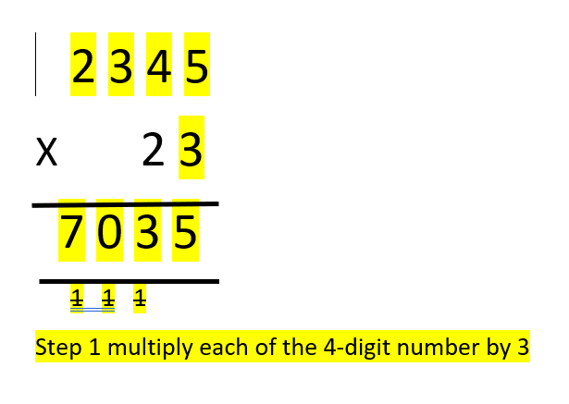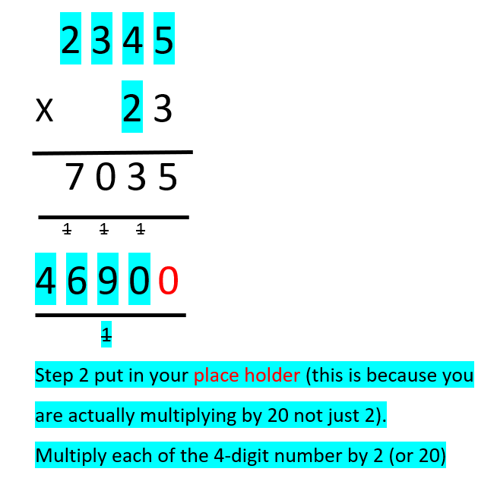
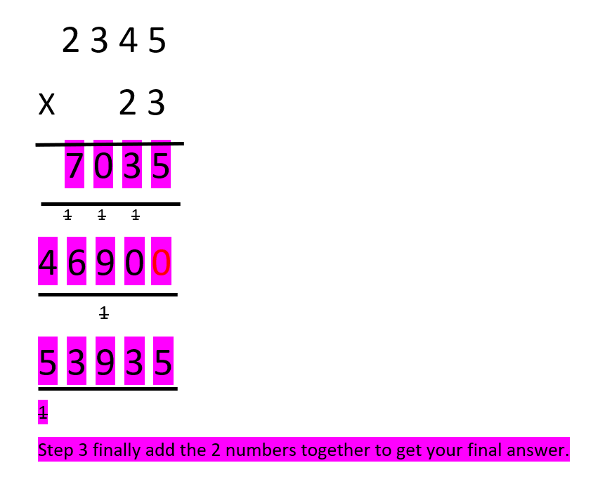
For more information visit - https://www.mathsisfun.com/numbers/multiplication-long.html

Short Division
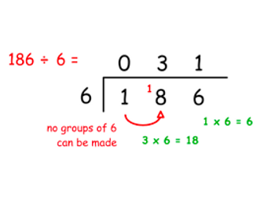
As a school, we teach long division in a specific way using a method called speed writing (which uses their knowledge of times tables). If your child is not secure with their times tables then they will not have currently accessed speed writing. Therefore, if your child is struggling with long division we will support them at school as the method is very tricky to translate through writing.

