Fraction based calculations

To add and subtract fractions there are Three Simple Steps:
- Step 1: Make sure the bottom numbers (the denominators) are the same – if they are then you need to find a common denominator. It is important that you multiply both top and bottom by the same amount to keep the value of the fraction the same
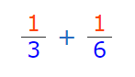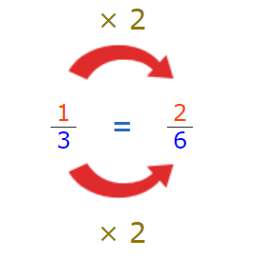

- Step 2: Add the top numbers (the numerators), put that answer over the denominator
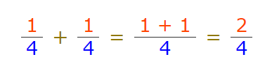
- Step 3: Simplify if needed
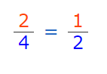
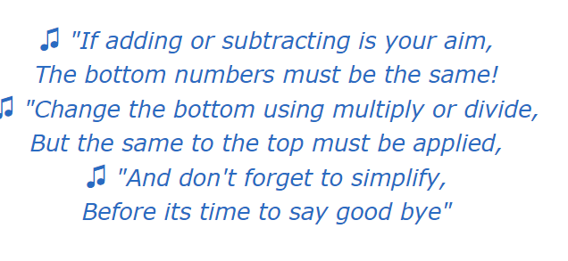
For more information visit - https://www.mathsisfun.com/fractions_addition.html

There are 3 simple steps to multiply fractions
Step 1: Multiply the top numbers (the numerators).
Step 2: Multiply the bottom numbers (the denominators).
Step 3: Simplify the fraction if needed.
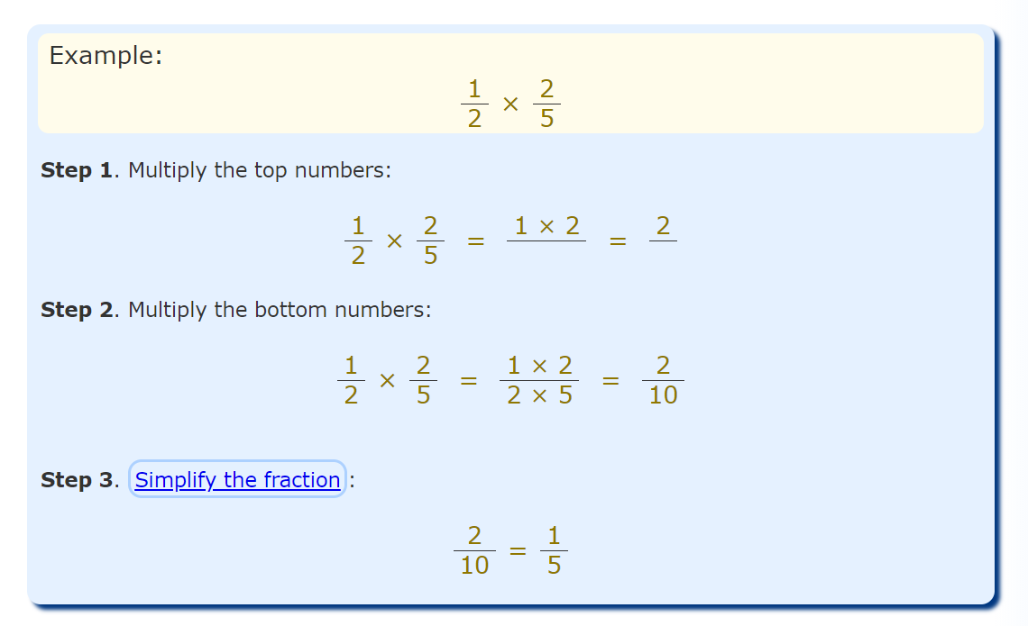
If you are multiplying a fraction by a whole number - make the whole number a fraction, by putting it over 1.

Then repeat as above!



For more information visit - https://www.mathsisfun.com/fractions_multiplication.html
There are 3 simple steps to divide fractions:
Step 1. Turn the second fraction (the one you want to divide by) upside down (this is now a reciprocal).
Step 2. Multiply the first fraction by that reciprocal
Step 3. Simplify the fraction (if needed)
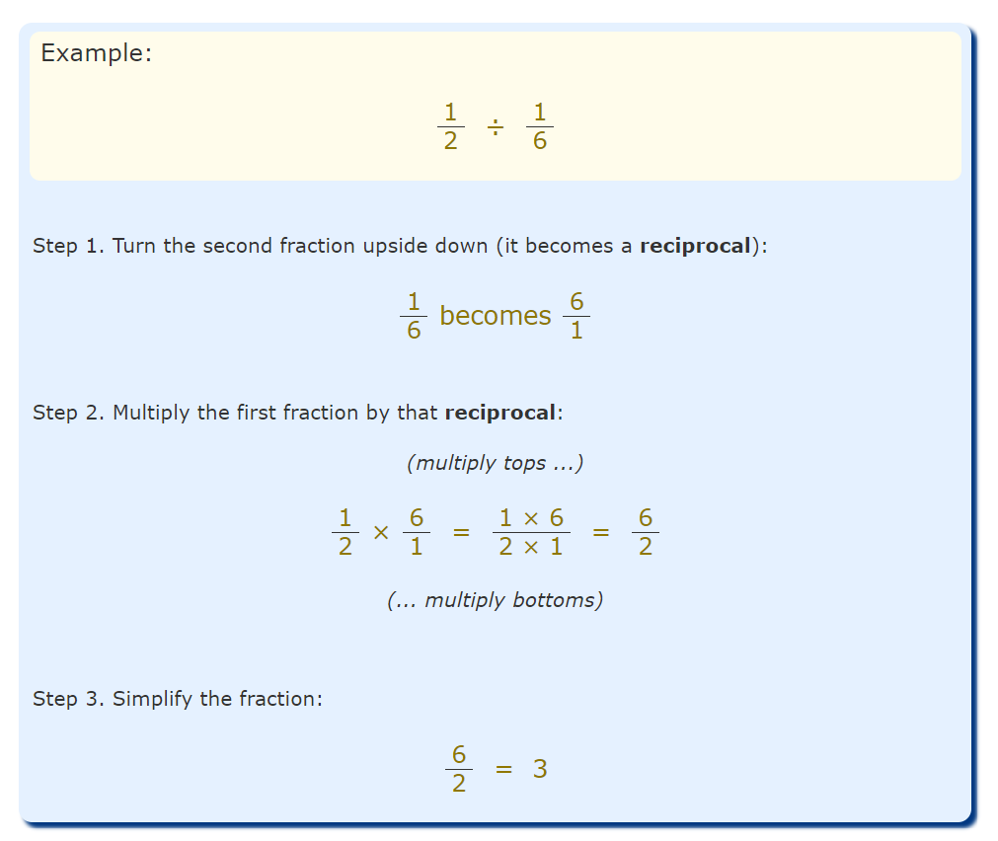



For more information visit - https://www.mathsisfun.com/fractions_division.html

